**Fall Semester 2022**

**School of Computer Science and Engineering**

The Sign Language Detection Application

REVIEW REPORT

Prepared For

**PHY1901 Introduction to Innovative Projects  
PROJECT COMPONENT**

Submitted To

**Dr. Shobana M K  
Assistant Professor Sr. Grade 2**

Submitted by

**Sankalp Mukim 20BDS0128**

**Arjun Deshraj 20BCE0846**

**Swarup Kharul 20BCT0070**

**Sumona Sud 20BDS0156**

**Sahil Garg 20BDS0174**

**Harshal Kate 20BDS0096**

**Sujit Bagdure 20BDS0098**

**Karnik Kanojia 20BDS0380**

**Abstract**

According to the World Federation of the Deaf, there are more than 70 million deaf people worldwide. More than 80% of them live in developing countries. Collectively, they use more than 300 different sign languages.

Sign languages are fully fledged natural languages, structurally distinct from the spoken languages. There is also international sign language, which is used by deaf people in international meetings and informally when travelling and socializing. It is considered a pidgin form of sign language that is not as complex as natural sign languages and has a limited lexicon.

The Convention on the Rights of Persons with Disabilities recognizes and promotes the use of sign languages. It makes clear that sign languages are equal in status to spoken languages and obligates states parties to facilitate the learning of sign language and promote the linguistic identity of the Deaf community.

According to the 2011 census of India there are 7 million active sign language users and only 250 certified interpreters of the whopping 1.36 billion population. We recognized the need to bridge this gap and create an inclusive community for them.

The purpose of the sign language detection system is to improve communications between people who do not know sign language and those who do. It is essentially googled translate for everyone who can communicate using sign language and those who cannot. In today's world, there are many who are put at a disadvantage when it comes to opportunities and access to simple things such as good quality education, health care etc.

**Table of Contents**

1. **Introduction4**
2. **Literary Survey4**
   1. Paper 1: Hand Detection on Sign Language Videos4
   2. Paper 2: Effectiveness of Colour-Based Hand Tracking6
3. **Project Explanation7**
   1. Full Explanation7
   2. Problem Solved7
   3. Tech Stack8
   4. Result and Snapshots9
4. **Conclusion10**
5. **References`10**
6. **Introduction**

Communication is very crucial to human beings, as it enables us to express ourselves. We communicate through speech, gestures, body language, reading, writing or through visual aids, speech being one of the most commonly used among them.

Sign Language chiefly uses manual communication to convey meaning. This involves simultaneously combining hand shapes, orientations and movement of the hands, arms or body to express the speaker's thoughts. Conversing with people having a hearing disability is a major challenge. Deaf and Mute people use hand gesture sign language to communicate, hence normal people face problems in recognizing their language by signs made.

Hence there is a need for systems that recognize the different signs and conveys the information to normal people. Sign Language consists of fingerspelling, which spells out words character by character, and word level association which involves hand gestures that convey the word meaning.

1. **Literary Survey** 
   1. **Hand Detection on Sign Language Videos**

Hand shape and motion are the main factors that distinguish one sign from another when it comes to gestures and sign language comprehension. Making an effective and trustworthy hand detector is thus a crucial first step in understanding signs and gestures. In this research paper, Zhong et al.[1], three hand detection techniques—a skin and motion detector, a hand detection approach employing several proposals, and a chains model—are assessed using three sets of sign language data. In the paper, the researchers discuss four methods for hand sign detection using computer vision – appearance-based hand detection, detecting hands as part of the human pictorial structure, hand-tracking, and hand shape detection.

The first method involves using skin color to localize and track hands. A way of detecting hands and their orientation using skin color, hand shape and context. This is used to study a view-specific hand posture detection with an object recognition method.

The second method – detecting hands as a part of human pictorial structure – proposes a full model that accounts for the arms' self-occlusion and uses a generative model for upper body detection. This is shown to be a difficult problem that can be solved by reducing it to an equivalent convex problem with a small, polynomial number of constraints. Then, we must develop a chain model where the relation between context features and the object of interest is modeled using an ensemble of feature chains. A hand and arm tracker detects joint positions in continuous sign language sequences. The method performs tracking in real time using a frame-by-frame random forest regressor.

The third method describes a way for 2D hand tracking. It proposes a temporal filtering framework for hand-tracking. In each frame, simple features like color and motion residue are exploited to identify multiple candidate hand locations. The temporal filter then uses Viterbi algorithm to select among the candidates from frame to frame. Then we use a binary quadratic equation to integrate appearance.

The fourth method proposes a way for detecting shapes of variable structures in images with clutter. Variable structure means that some shape parts can be repeated an arbitrary number of times. A new class of shape models is introduced, called the Hidden State Shape Models. Then a detection algorithm is described that finds instances of shapes and creates models.

The paper also describes a way to detect motion and skin. We detect skin because the color of human skin is often consistent, one may use a statistical color model to determine the likelihood that each pixel will be skin-colored. We describe a skin likelihood distribution using P(skin|r,g,b).

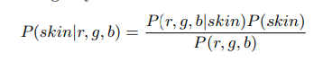

Temporal motion is another useful clue for hand detection since a user needs to move hands to create a gesture. To detect motion, we use a simple method based on frame differencing. Frame differencing works with the following formula.

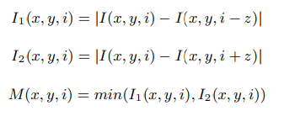

The researchers[1] conduct their experiments in a user independent manner using three sign language video datasets. The hand detection is considered to be correct if its within a half face width from the ground-truth location of the hand. If the ground truth is within half the face width of one of the top k candidates, it is considered accurately located. The one- handed and two-handed test cases are examined separately.

Hence, the paper shows us a way to create the model behind the sign language detection app.

* 1. **Effectiveness of Colour-based Hand Tracking**

In many interactive applications, such as tracking faces and hands in video databases and identifying people, skin colour detection is commonly used. The purpose of this study was to demonstrate the effectiveness of a color-based hand tracking method.

This colour space distribution technique segments the hand from the background in real time. This method offers the following advantages: In order to speed up tracking, the segmentation procedure is carried out simultaneously in an area surrounding the hand.

In various lightning situations, this method is quite resilient. In order to evaluate the effectiveness of the adopted technique, a variety of experiments have been conducted.

1. **Project Explanation**
2. **Full explanation**

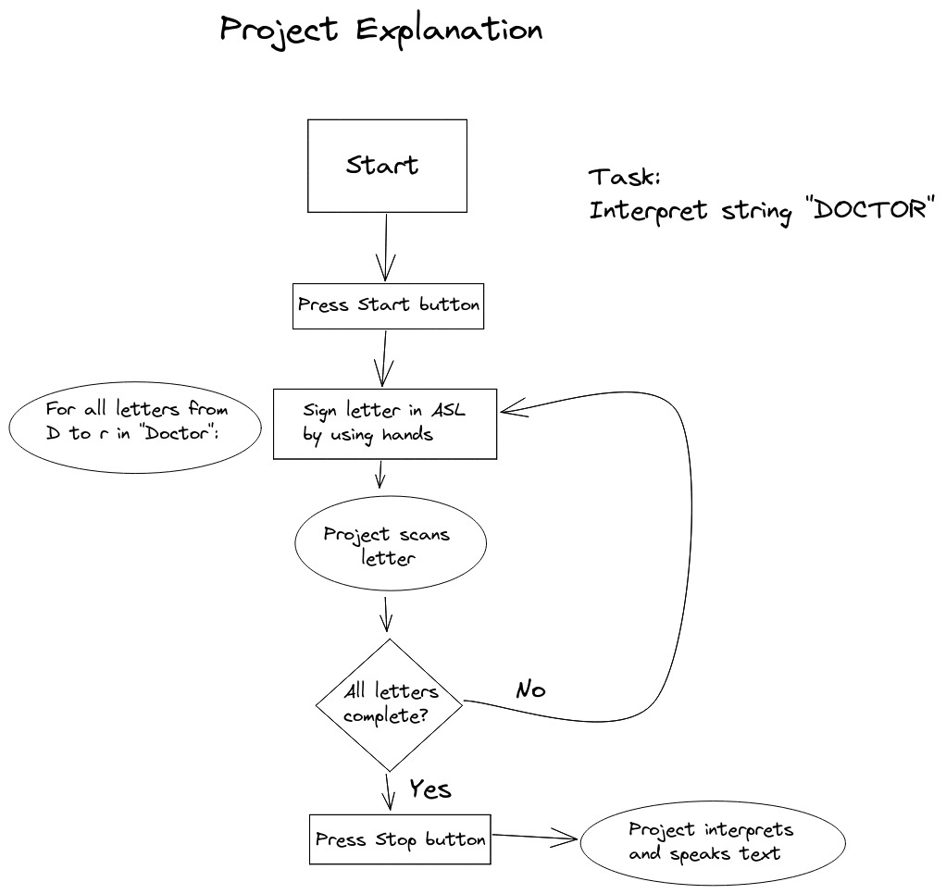

1. **Problem Solved**

According to the 2011 census of India, among the immense 1.36 billion population of our country, a paltry 250 people are certified sign language interpreters. 250 people to help a population of a billion interact and communicate with 7 million active sign language users.

In today’s world, more than ever before, it is of utmost importance to be as inclusive as possible to everyone so that no matter what their circumstances, they are provided with equal opportunities. This is simply not possible without being able to communicate with these sign language users. Regardless of their disability, they should not be excluded from anything and deserve the right to be provided with equal opportunities. Our project is a small step towards achieving this goal.

Our web app enables users to use sign language to communicate with non sign language users by translating basic ASL into letters which ultimately can be used to form words and sentences. This is integral as it also enables non sign language users to learn basic sign language and help ease differently abled people to communicate and help make their lives just slightly easier.

It is completely free and open for all to use along with cross-platform support to make it completely accessible to everyone. There are so many who are put at a disadvantage when it comes to opportunities and access to the simplest of things due to their different language which very few are capable of understanding and using. This unfair disadvantage, we hope, will be reduced with the help of our project, which we hope will not only help these disadvantaged people but also promote the learning of sign language everywhere.

1. **Tech Stack**

The tech stack used in the project is:

1. TensorFlow
2. Python
3. Gunicorn
4. React.js
5. MongoDB
6. Docker
7. Heroku
8. Nginx
9. **Results and Snapshots**

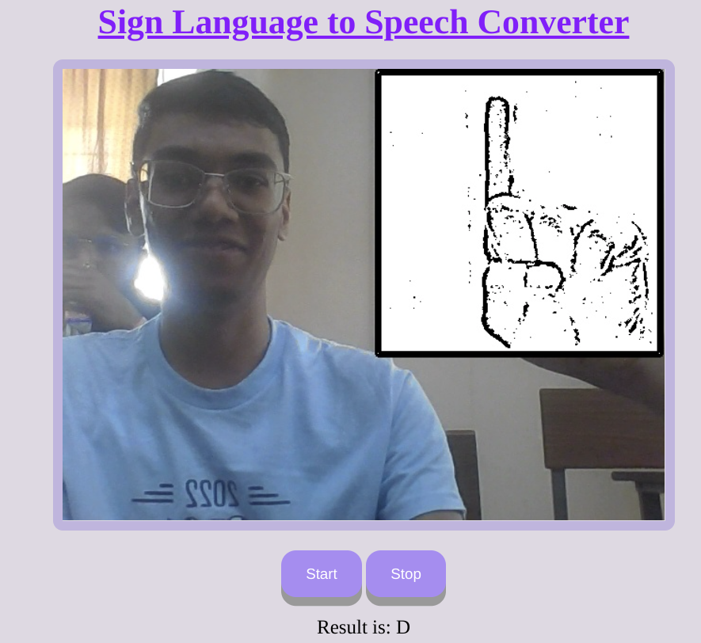

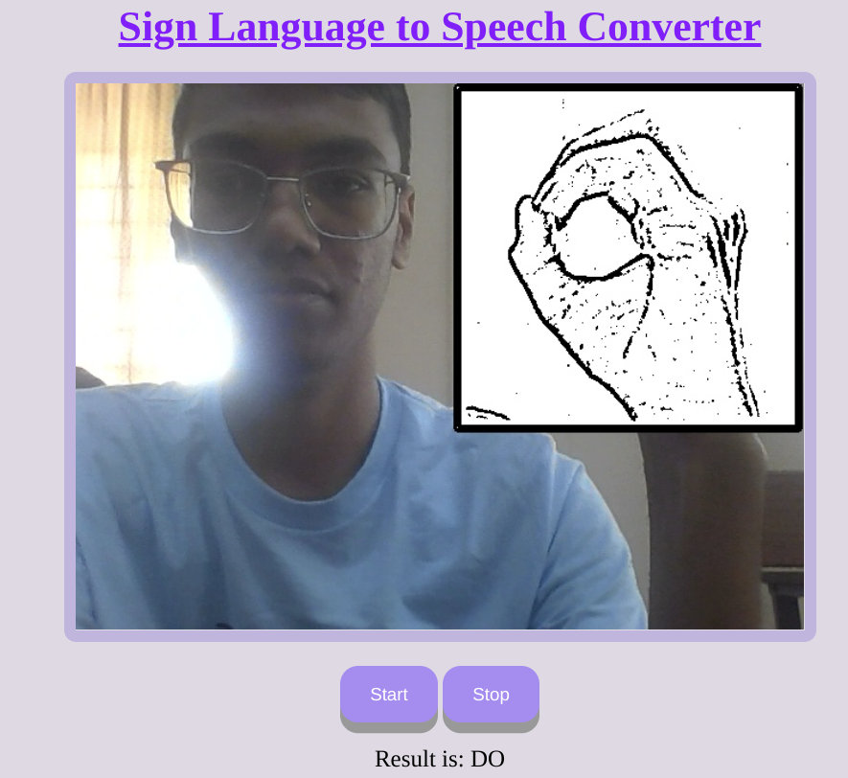

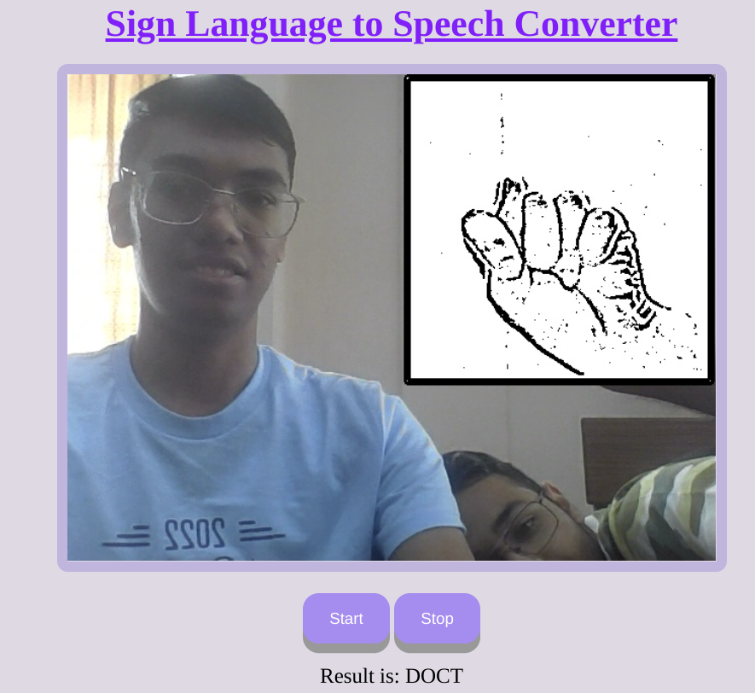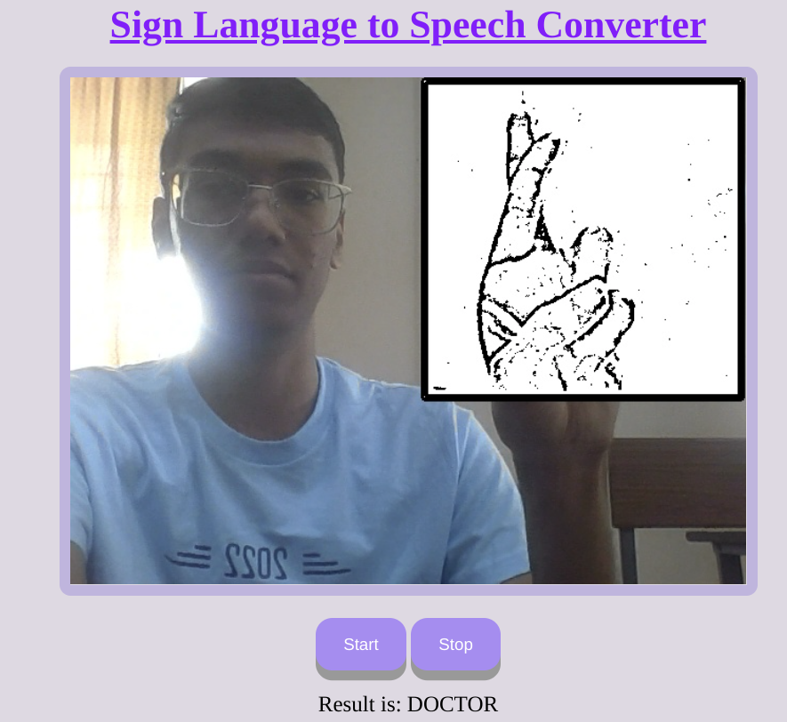

1. **Conclusion**

Sign languages are kinds of visual languages that employ movements of hands as a means of communication. Sign languages are important for specially abled people to have a means of communication. Through it, they can communicate and express and share their feelings with others. The drawback is that not everyone possesses the knowledge of sign languages which limits communication.

This limitation can be overcome using automated Sign Language Recognition systems which will be able to easily translate the sign language gestures into commonly spoken language. It is done by TensorFlow object detection API.

The system has been trained on the Indian Sign Language alphabet dataset. The system detects sign language in real-time. For data acquisition, images are captured by webcam using Python and OpenCV. The TensorFlow model that has been used can be interchanged with another model as well.

1. **References**
2. <https://towardsdatascience.com/american-sign-language-recognition-using-cnn-36910b86d651>

Testing different CNN (Neural Networks) techniques for image analysis.

1. Zhong Zhang, Christopher Conly, and Vassilis Athitsos. 2014. Hand detection on sign language videos. In Proceedings of the 7th International Conference on PErvasive Technologies Related to Assistive Environments (PETRA '14). Association for Computing Machinery, New York, NY, USA, Article 26, 1–5. <https://doi.org/10.1145/2674396.2674442>
2. <https://www.frontiersin.org/articles/10.3389/fpsyg.2019.00483/full>

Explains in detail the meaning, relevance, and advantages of Sign Language

1. <https://www.ijert.org/a-review-paper-on-sign-language-recognition-for-the-deaf-and-dumb>

Explains how sign language solves communication problems for the deaf and dumb.

1. <https://research.google/pubs/pub45381/>

Talks about Tensorflow (The library used to implement Neural Network models)

1. <https://arxiv.org/pdf/1905.05487.pdf>

Another Research paper explaining results in the field of ASL recognition